# **Apply filters to SQL queries**

## **Project description**

Through SQL the goal is to look into different departments' data within the organization. Through application of filters within SQL I will find:

* Any login attempts that occurred after hours
* Login attempts from specific dates
* Login attempts outside of Mexico
* A list of employees in Marketing
* A list of employees in Finance or Sales
* A list of all employees not in IT

## **Retrieve after hours failed login attempts**

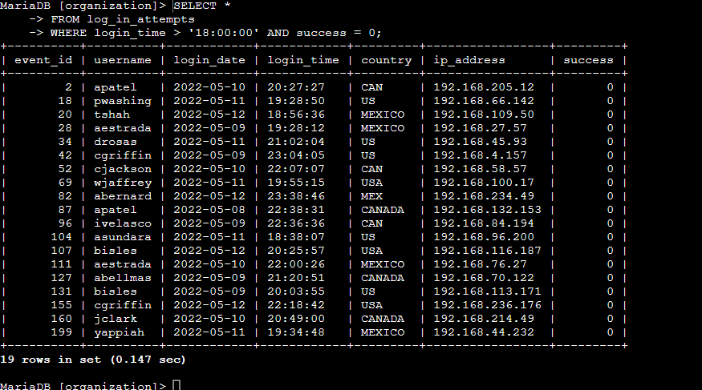

The SQL query used selects all columns (**SELECT\***) within the log_in_attempts table (**FROM log_in_attempts)**, and specifically retrieves login attempts that are from after 18:00 (**WHERE login_time > ‘18:00:00’)** and failed to go through (**AND success = 0**). By using ‘AND’ in a query, it allows searching for results that fulfill multiple conditions (in this case the login time and an unsuccessful login). In order to search for logins attempted after hours, a greater than symbol (>) is used before the selected time (18:00:00).

## **Retrieve login attempts on specific dates**

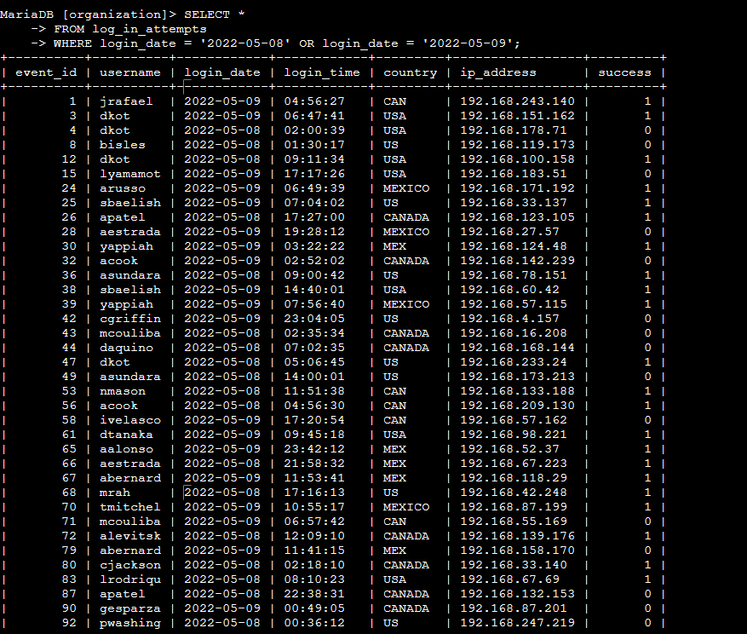

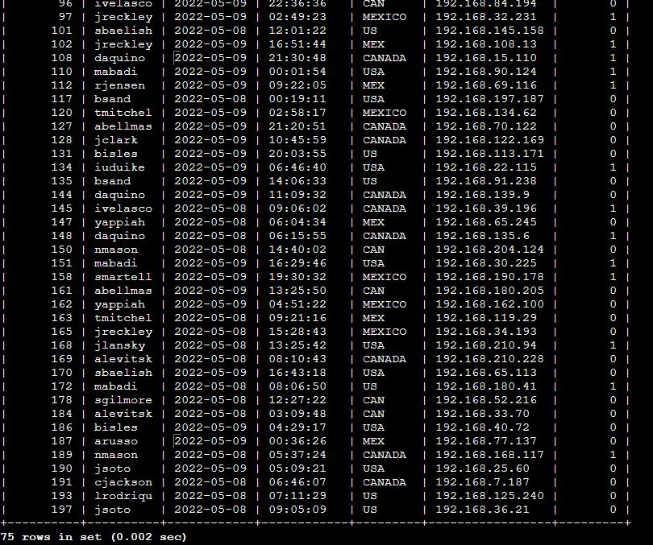

The SQL query used selects all columns (**SELECT\***) within the log_in_attempts table (**FROM log_in_attempts)**, and specifically retrieves login attempts that are from May 8th 2022 or March 9th 2022 **(WHERE login_date = ‘2022-05-08’ OR login_date = ‘2022-05-09’).** By using the OR filterfor this query, we are able to retrieve attempts from multiple different dates (in this case May 8th or May 9th 2022).

## **Retrieve login attempts outside of Mexico**

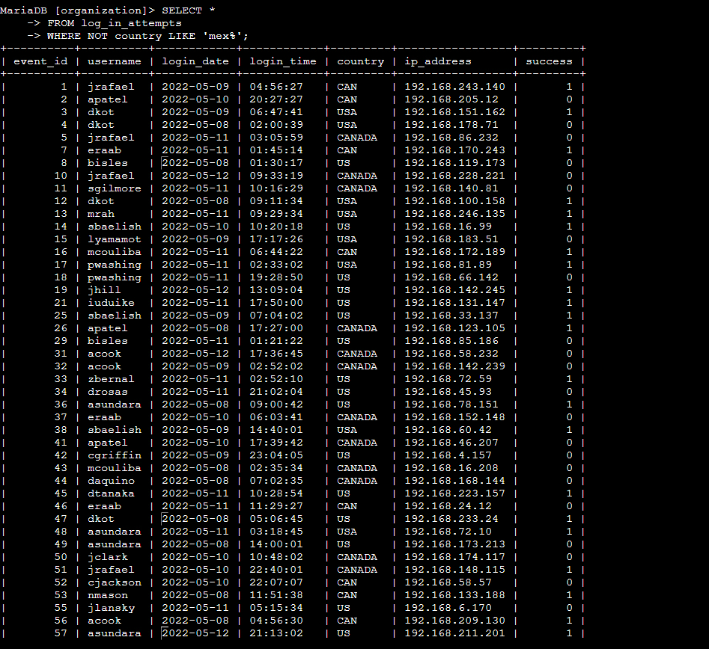

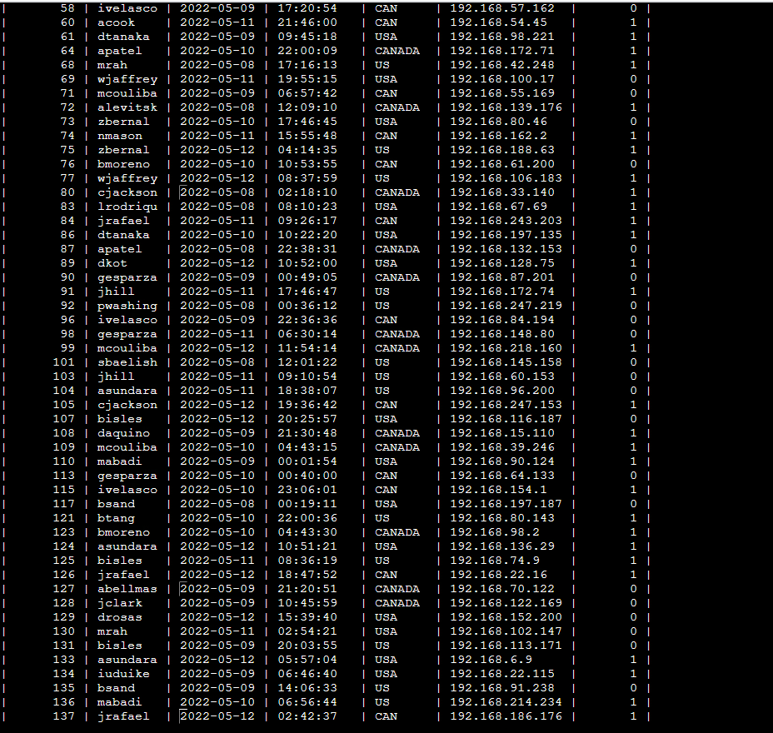

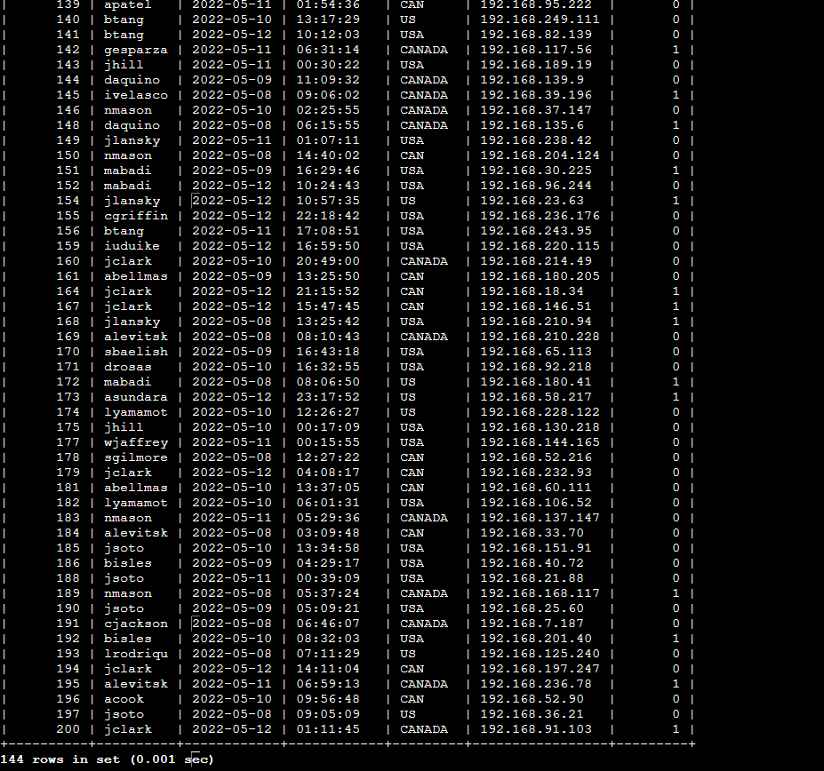

The SQL query used selects all columns (**SELECT\***) within the log_in_attempts table (**FROM log_in_attempts**), and specifically retrieves login attempts that are not from Mexico (**WHERE NOT country LIKE ‘Mex%’**). By using the ‘NOT’ filter after WHERE, SQL pulls results that are not equal to the data input after (in this case ‘Mex%’). Users are able to input both ‘Mex’ and ‘Mexico’ for the country of Mexico, so by inputting “LIKE ‘Mex%’” it will encompass both results. The percent symbol (%) input after text is used to encompass a wider variety of data when the letters or numbers after are unknown or variable.

## **Retrieve employees in Marketing**

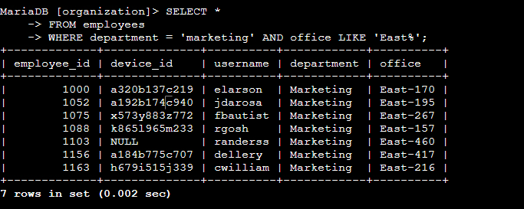

The SQL query used selects all columns (**SELECT\***) within the employee table (**FROM employees)**, and specifically retrieves employees that are from the marketing department and in the East Offices (**WHERE department = ‘marketing’ AND office LIKE ‘East%’**). By using the **AND** filter, we are able to select employees that are both in the marketing department AND in the East Offices. Using the **LIKE** filter in combination with ‘**East%’** will return back with any result that starts with “East”, which will include all the east offices that have numbers proceeding afterwards.

## **Retrieve employees in Finance or Sales**

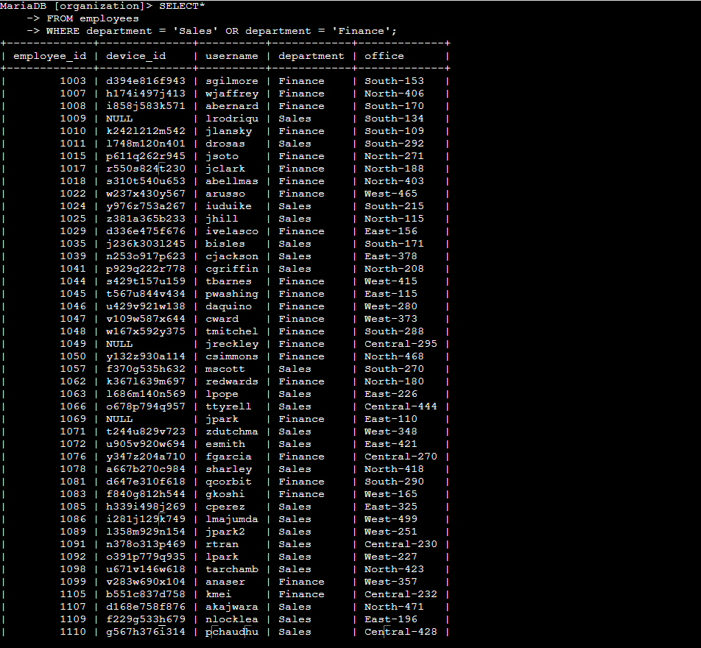

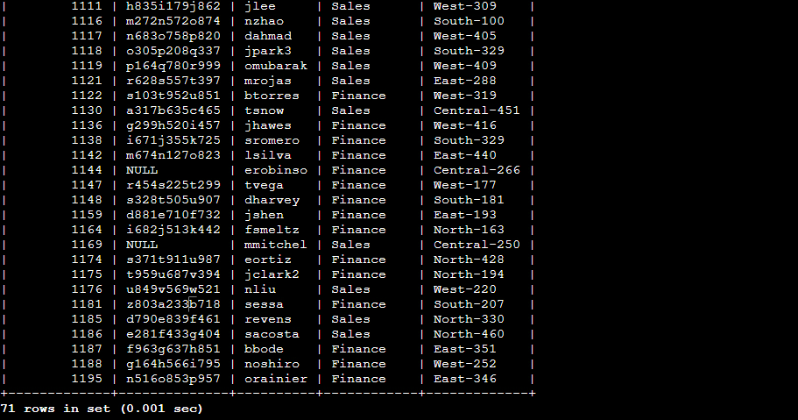

The SQL query used selects all columns (**SELECT\***) within the employee table (**FROM employees)**, and specifically retrieves employees that are from either Finance or Sales (**WHERE department = ‘Sales’ OR department = ‘Finance’)**. Using the OR filter in combination with multiple queries will return results from either of the two categories provided (Finance or Sales in this situation).

## **Retrieve all employees not in IT**

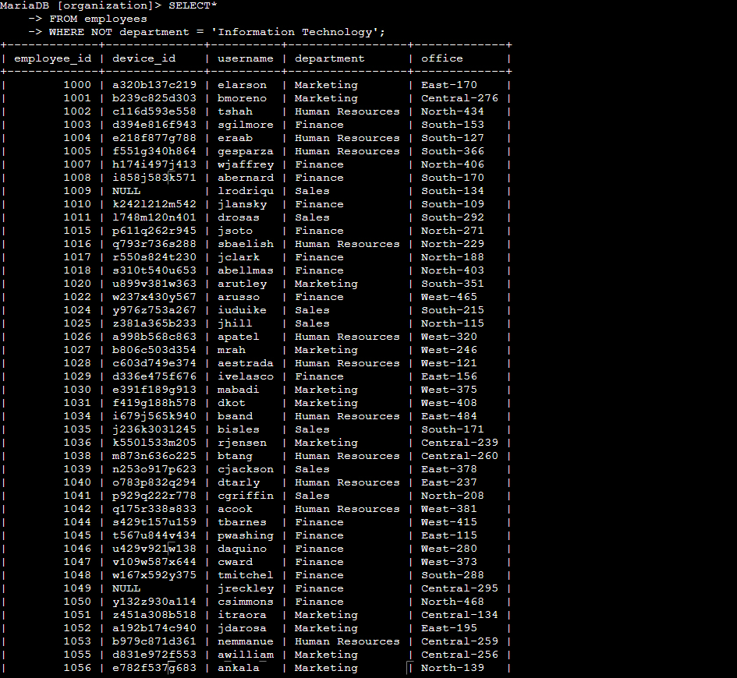

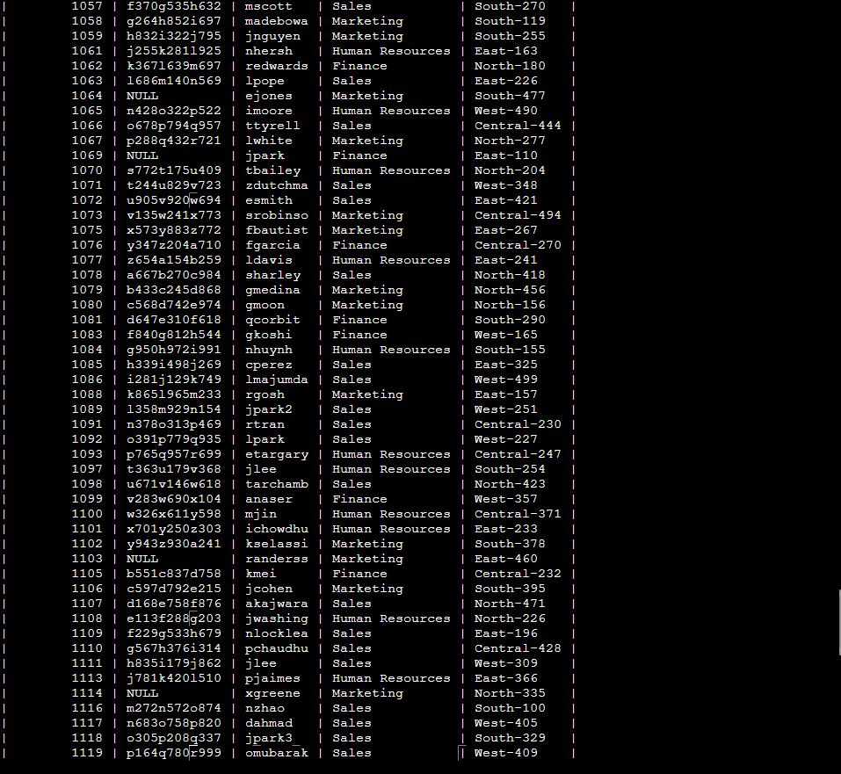

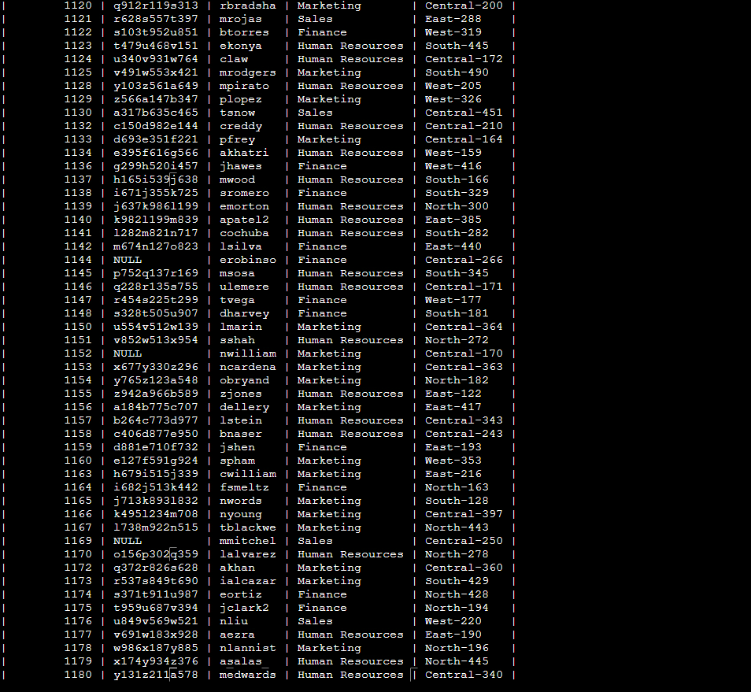

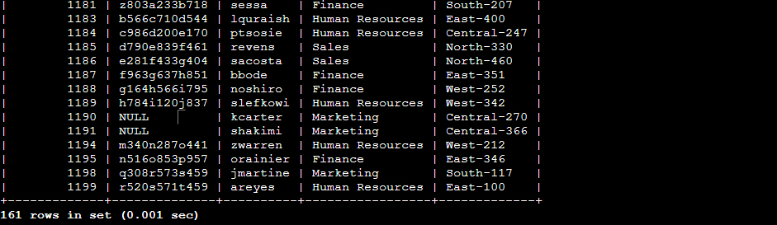

The SQL query used selects all columns (**SELECT\***) within the employee table (**FROM employees)**, and specifically retrieves employees that are NOT in the Information Technology department (**WHERE NOT department = ‘Information Technology’)**. Using the NOT modifier to our WHERE filter will return all results that do not match the provided category (In this case every employee that does not work in the IT department).

## **Summary**

By using different filters in combination with SQL queries, it’s much easier to get more specific results catered to what is being looked for within different databases. The OR, NOT, and AND filters allow for much quicker processing through data across a variety of instances.